Module 2 Challenge:

2018 Stock listings scorecard

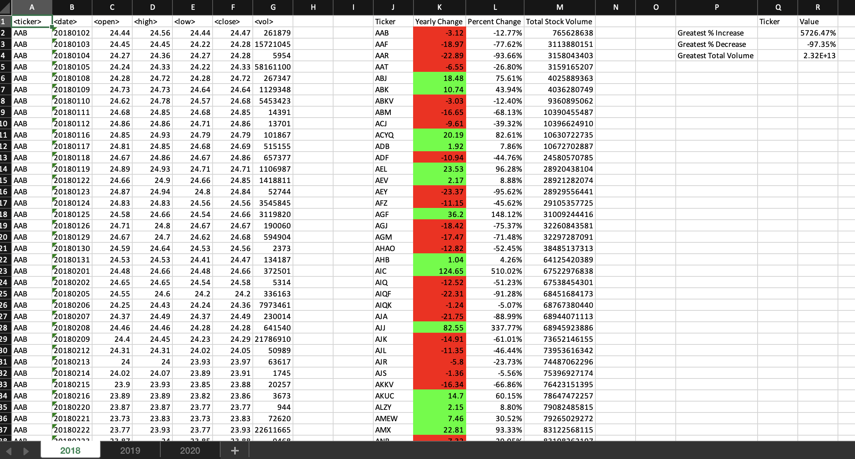

2019 Stock listings scorecard

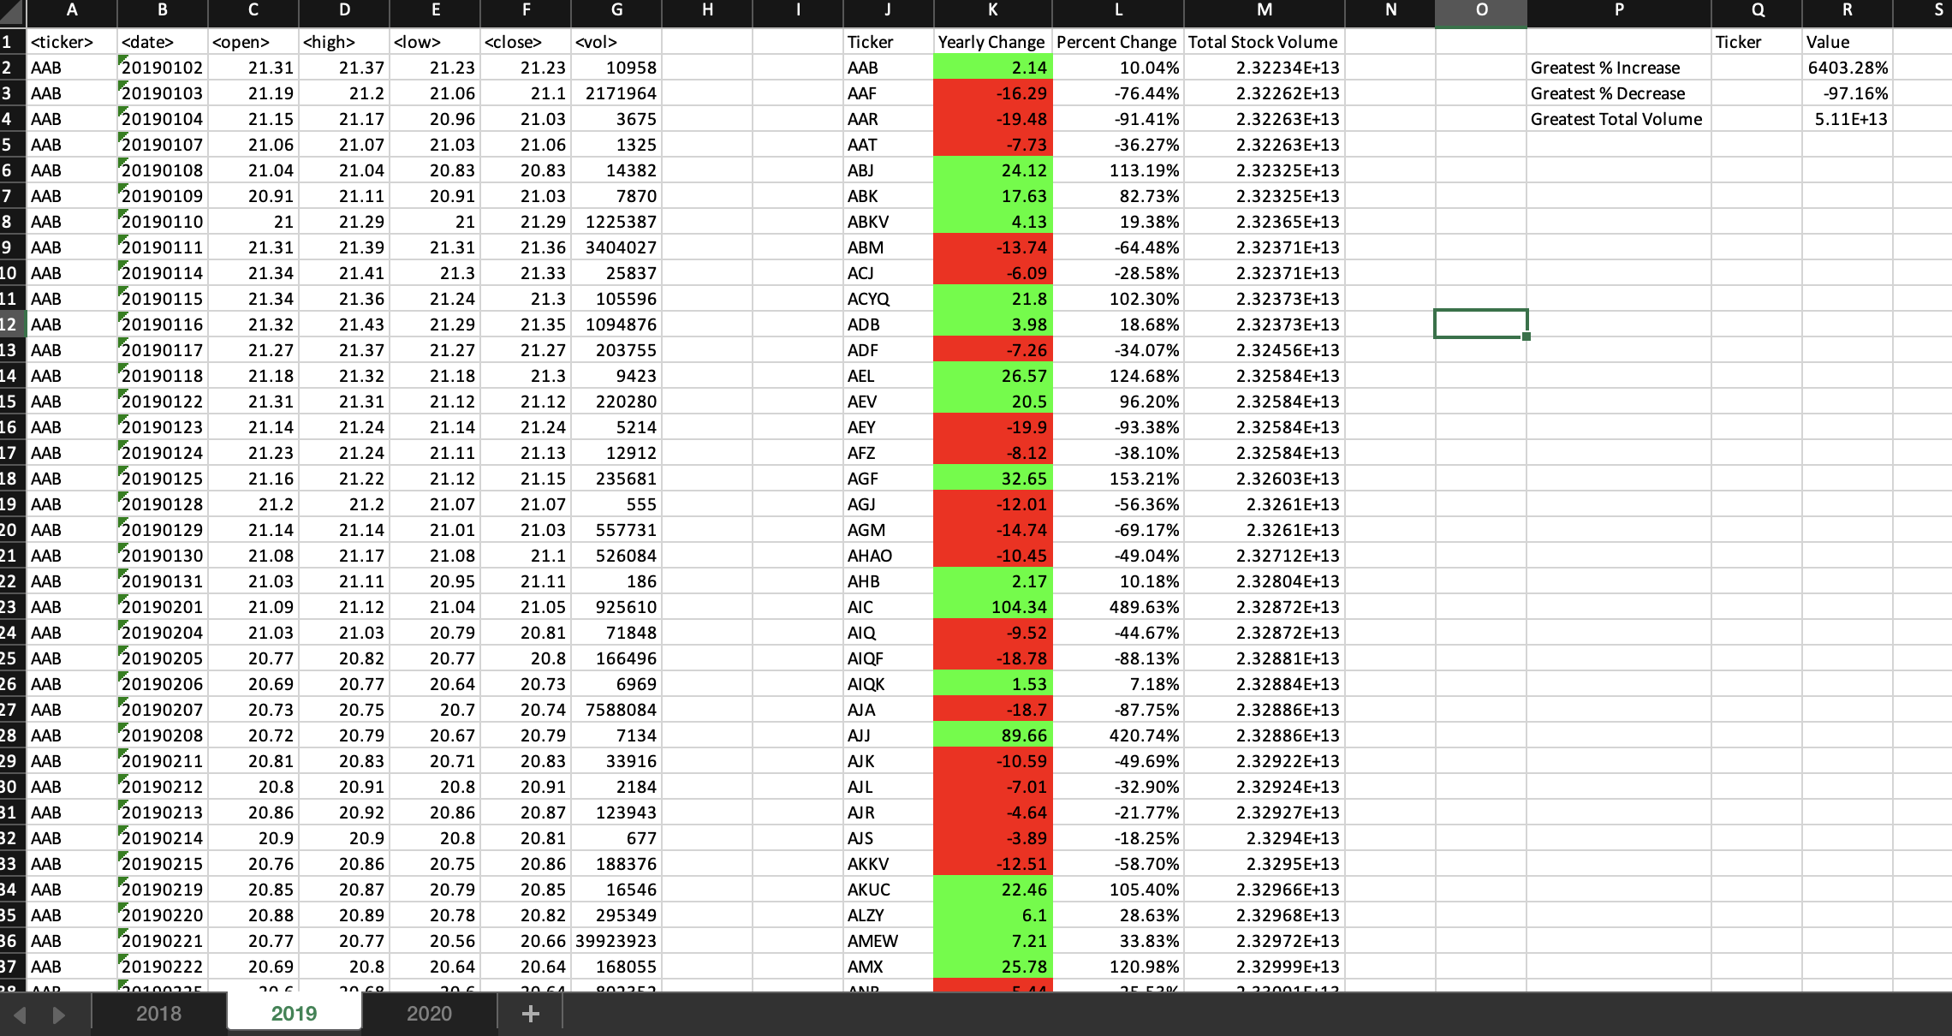

2020 Stock listings scorecard

